PENRHOS COLLEGE
YEAR 12 PHYSICS EXAMINATION
SOLUTIONS TO SEMESTER 1 REVISION
Name: _____________________________ Teacher: __________________
TIME ALLOWED FOR THIS PAPER
Reading time before commencing work 10 minutes
Working time for paper 3 hours
MATERIAL REQUIRED/RECOMMENDED FOR THIS PAPER
TO BE PROVIDED BY THE SUPERVISOR
This Question/Answer booklet
Physics: Formulae and Constants Sheet
TO BE PROVIDED BY THE CANDIDATE
Standard items: Pens, pencils, eraser, ruler
Special items: MATHOMAT and/or Mathaid, compass, protractor, set square and graphics calculators satisfying the conditions set down by the Curriculum Council
IMPORTANT NOTE TO CANDIDATES
No other items may be taken into the examination room.
It is your responsibility to ensure that you do not have any unauthorised notes or other items of a non-personal nature in the examination room. If you have any unauthorised material with you, hand it to the supervisor BEFORE reading any further.
STRUCTURE OF PAPER
Section | No. of questions | No. of questions to be attempted | No. of marks set out of 130 | Proportion of examination total
A: Short Answers | 15 | ALL | 60 | 30%
B: Problem Solving | 6 | ALL | 100 | 50%
C: Comprehension | 2 | ALL | 40 | 20%
INSTRUCTIONS TO CANDIDATES
Write your answers in the spaces provided beneath each question. The Physics: Formulae and Constants Sheet may be used as required.
Graphics calculators satisfying Curriculum Council requirements may be used to evaluate numerical answers.
Answers to questions involving calculations should be evaluated and given in decimal form. Choose an appropriate number of significant figures, usually no more than three. Despite an incorrect final result, credit may be obtained for method and working, providing these are clearly and legibly set out.
Questions involving the instruction "ESTIMATE" may give insufficient numerical data for their solution. Students should provide appropriate figures to enable an approximate solution to be calculated.

PART A: SHORT ANSWERS
Marks Allotted: 60 marks out of 200 (30%)
Attempt ALL 15 questions in this section. Each question is worth 4 marks. Answers are to be written in the space indicated.
1. A solenoid coil carrying current has a magnetic field around it. The coil is wound onto a hollow plastic cylinder. Describe two ways by which this field can be increased in strength.
Increase current
More turns
Insert iron rod
Any 2 will do

2. Calculate the maximum torque output of a circular coil of radius 8.00 cm mounted so that it can spin freely between the poles of a pair of bar magnets. The magnetic field is of strength 3.00T. The coil has 20 turns, and carries a current of 4.00A.
T = BIAN sinθ
T = 3.00 X 4.00 X π X .08² X 20 X sin 90
T = 4.82 N m

3. A horizontal piece of wire of length 25.0 cm carries a current if 125 mA in a northerly direction through a strong magnetic field which is directed vertically downwards. The resulting magnetic force on the wire is 52.5 x 10⁻³ N. Calculate the strength of the field, and the direction of the magnetic force.

F = BIl
52.5 x 10⁻³ = B x 0.125 x 0.25
B = 1.68 T
Force is toward the West

4. A compass is placed on a table top. A bar magnet lies nearby on the table top with its long axis pointing east-west. The horizontal component of the Earth’s magnetic field in this region is 1.60 x 10⁻⁵ T. The compass is deflected by 30.0° away from magnetic north by the presence of the bar magnet. On the diagram below draw in the magnetic field intensity vectors of the Earth and the bar magnet, and calculate the strength of the bar magnet’s field at the spot where the compass is positioned.

W
1.60 x 10 ⁻⁵ x tan 30 = B_{magnet}
Bar magnet
B_{magnet} = 9.24 x 10 ⁻⁶ T
S
5. There are two formulas for magnetic force, F = Bqv, and F = BI. By substituting the dimensions or units of the quantities in each formula prove that they are dimensionally consistent.
B q v = B I l
B (I t) v =B I l
B (I t x l/t) B I l
B I l =B I l

6. A small lap-top computer operates on 15.0 V and 2.00 A. The lap-top is connected to a step-down transformer, and this transformer is then connected to the mains supply. Calculate the turns ratio of the transformer. (Assume the transformer is 60% efficient)
Primary Power P = Secondary Power
V_{P} I_{P} = V_{s} I_{s}
240 x I_{P} = 15.x.2
I_{P} = 0.125A

7. A mass of 20kg is acted on by three horizontal forces. They are 20N at an angle of N 30⁰E, 20N at an angle of N 30⁰W, and 60N S. Calculate the nett force acting on the mass.
North +, East +
Vector | North/South | East/West
20 N 30E | +20 cos30  +17.32 | +20 sin30  +10
20 N 30W | +17.32 | -10
60 S | -60 | 0
F_{nett} | -25.4 | 0
A = F/m
A = 25.4/20 = 1.27 m s⁻² South

8. An astronaut tossed a stone vertically upwards at 6.00 m s⁻¹ from 1.25 m above the surface of a planet, X. The stone landed again 5.02 s later. On the basis of this information, calculate the acceleration due to gravity at the surface of planet X.
s = u t + 0.5 g t²
-1 25= 6 x 5.02 -0.5 x g x 5.02²
g = 2.49 m s⁻²

9. The record for a drag racer covering a standing quarter mile (about 400 m) is 5.60 s. Assuming that the dragster accelerates at a constant rate, calculate the dragster’s acceleration, and its final speed.
s = u t + 0.5 g t²
400 = 0 + 0.5 x a x 5.60²
a = 25.5 m s⁻²
v = u +a t
v = 0 + 25.5 x 5.60
v = 143 m s⁻¹
10. The dragster that made the record run (question 9, above) was actually travelling at 402 km h⁻¹ at the end of its run. In the light of your answer to question 3, comment on the dragster’s acceleration.
Air drag reduces final velocity
Or
Non constant acceleration

11. Satellite measurements indicate that Africa and South America are separating at 1.5 cm a year. This is because the ocean floor is splitting apart along a mid-ocean ridge, where new rock material is constantly being added to the ocean floor. The rocks on an island in the South Atlantic are about 27 million years old. How far is this island from the mid-ocean ridge? Show your reasoning.
S = v_{av} x t
S = 1.5 x 10⁻² x 27 x 10⁶
S = 4.05 x 10⁵ m.
Divide this by 2 since the spread is equal in both directions. Therefore distance = 2.02 x 10⁵ m

12. The diagram shows part of the path of a flying golf ball. Account for the shape of the path, and mark clearly the direction and relative size of the acceleration at the points A and B.
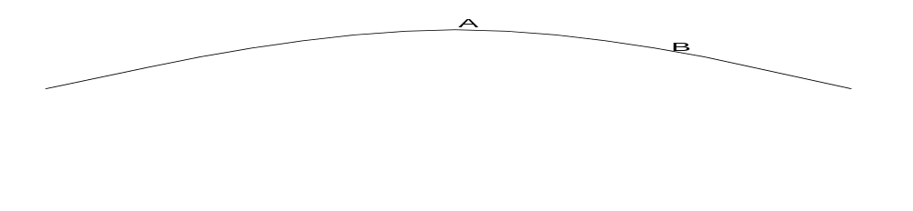Shape is parabolic because of constant vertical acceleration, and zero horizontal acceleration.
13. Jill placed a toy car of mass m on a looped track as shown. When she released it, the car entered the loop which had radius r. The car completed the loop without falling away from the track. Write an expression in terms of the symbols g and r, for the minimum speed v that the car must have had at point P.
v_{min} ² = r x g

14. The Sydney organisers plan to build an Olympic standard roller-skating banked track. The consulting engineer wants to bank one bend in the track such that a skater of mass 75.0 kg moving at 18.0 m s⁻¹ can safely negotiate the curve. The horizontal radius of the circular path at this point is to be 40.0 m. Ignoring friction, calculate the angle at which the track should be banked. (Assume that the vector sum {normal reaction force from the slope plus the weight force} provides the necessary centripetal force.)
tanθ = v² / (r x g)
tanθ = 18² / (40 x 9.8)
θ = 39.6°

15. When you drive a car around a corner, you feel a force from the side of the seat belt. Why? If you turn to the right, which side feels the force of the seat belt?
Your inertia keeps you travelling at a tangent to the circular arc
The seatbelt pulls you inwards
Your left side (since the force is to the right)

END OF PART A
PART B: EXTENDED ANSWER
Please answer the items in Part B in the spaces provided. Where a numerical answer is required, give the final result to three (3) significant digits unless instructed otherwise. This part of the examination consists of six questions and is worth 100 marks.
1. (14 marks) A bar magnet is pushed towards a solenoid coil at a constant velocity of 4.00 m s⁻¹. The solenoid has 5 turns and is of negligible resistance. The solenoid is connected to a resistor of resistance 8.00 Ω. While the magnet is moving towards the solenoid a steady current of 1.50 A is registered on the ammeter (see diagram below).

(a) (3 marks) Calculate the heating power developed in the resistor circuit.
P = I² x R
P = 1.50² x 8.00
P = 18.0w

(b) (3 marks) Calculate the EMF induced between the ends of the solenoid.
V = I R
V = 12.0V
(c) (4 marks) Using the answer that you calculated in (b) and Faraday’s Law of Induction, calculate the rate at which magnetic flux is being cut in this situation. Show your reasoning.
(Note. If you were unable to arrive at a numerical answer for part (b), select another value to complete part(c).)
ΔΦ /t = emf / N
ΔΦ /t = 12 / 5
ΔΦ /t = 2.40 Wb s⁻¹

(d) (4 marks) By applying the law of conservation of energy and any appropriate mechanical formula, calculate the size of the mechanical force needed to push the magnet at a constant rate.
Mechanical Power = Heating output power
Mechanical Power P = F x v
18 = F x 4
F = 4.50N
2. (16 marks) A square coil of area 0 04 m² is rotated in a uniform magnetic field of 0.300T at a rate of 2000rpm.
- ( 6 marks) Calculate the average EMF generated in the coil.
Emf_{av} = -N x (ΔΦ₂ - ΔΦ₁ ) / t
where t = T/4 = 60/(2000 x 4) =0.0075s
Emf_{av} = -1 x (BA - 0.00 ) / (0.0075)
Emf_{av} = -1 x (0.300 x 0.040 - 0.00 ) / (0.0075)
Emf_{av} = - 1.60V

- (2 marks) Draw a picture of the coil in the field at the instant this EMF is generated.

- (2marks) Select one form of energy that could act as the source of energy that feeds into the generator. Describe how this energy is introduced into the generator.
Kinetic Energy
The turbine turns an axle which rotates the coil or rotates the magnet.

- (3marks). The coil acts as a generator supplying power to a large electric oven used as a kiln to bake bricks. If the oven requires 300 kw to operate, completely describe the current that must be produced in the generator.
P = V x I
300 x 10³ = 1.60 x I
I = 1.88 x 10⁵ A AC 33.3 Hz

- ( 3marks) Sketch a graph of EMF vs time for the Voltage output of the coil if the rotation rate was doubled.
3.20
.015
Time
(s)
Emf
(V)

3. (16 marks) An electric train motor works best at voltages between 11 kV and 6kV. The electrified tracks are attached to a 12 kw power transformer which provides 11 kV to the tracks at a station at the start of a section of the track.. The electric current then feeds up through the steel wheels of the train, along the axle and into the electric motor. The other track is kept at 0V to act as a return conductor to the transformer.
(a) (3 marks) Calculate the resistance of the motor.
P V x I
12000 = 11000 x I
I = 1.09 A

V = I R
12000 = 1.09 x R
R = 11009Ω
(b) (3 marks) The track is made of steel beams that have a resistance of 2.00 Ω km⁻¹. This section of the track is 12.5 km long. Calculate the total resistance of the tracks in this section of the track.
R = (2x 12.5) 2.00
R = 50Ω

© (4 marks) Calculate the current flow to the train motor when it is at the end of this section of the track.
Total Current flow
I = V /R
I = 1100 / (11009 + 50)
I = 1100 / (11059)
I = 0.995A

(d) (3 marks) Calculate the power losses in the cable when the train is at the end of this section of the track.
Lost Power
P = I² .x R
P = 0.995² x 50
P = 49.5w

- (3 marks) What is the maximum length of track that could be used with this motor given its minimum voltage requirements? Show your reasoning.
If the minimum motor voltage is 6000V, then there must have been 5000V lost in the tracks.
This means 2500V along to the motor and 2500V back
V = I x R
2500 = 0.995 x R
R = 2512Ω
Therefore the length of the track is 2512/ 2.00 km = 1256 km
4. (16 marks) Observations of a satellite in a circular orbit around Mars give the following information:
Mass of satellite | Orbital radius | Acceleration towards Mars
394 kg | 25 000 km | 7.84 cm s⁻¹
Given that the radius of the planet itself is 3 500 km;
(a) (4 marks) Calculate the satellite’s orbital speed.
a_{c} = g
v² / r = g
v² = 7.84 x 10⁻² x 25000 x 10³
v = 1.40 x 10³ m s⁻¹

(b) (4 marks) What is its orbital period?
v (2 π r) / t
T = 1.12 x 10⁵ s
(c) (4 marks) Calculate the value of “g” at the surface of Mars.
g = G M / r²
7.84 x 10⁻² = (6.67 x10 ⁻¹¹ x M) / (25000 x 10³ )²
M = 7.35 x 10²³ kg
Surface value of g
g = G M / r²
g = (6.67 x10 ⁻¹¹ x 7.35 x 10²³ ) / (3500 x 10³ )²
g =- 4.00 m s⁻²
(d) (4 marks) If the satellite lands on the Martian surface, what will be its mass and weight on Mars?
W = m g = 394 x 4.00 = 1.58 x 10³ N
5. (18 marks) Max practised golf from the top of a city building. The ball accidentally sliced outwards, at a speed of 6.00 m s⁻¹ above the horizontal, towards another building 15.0 m away.
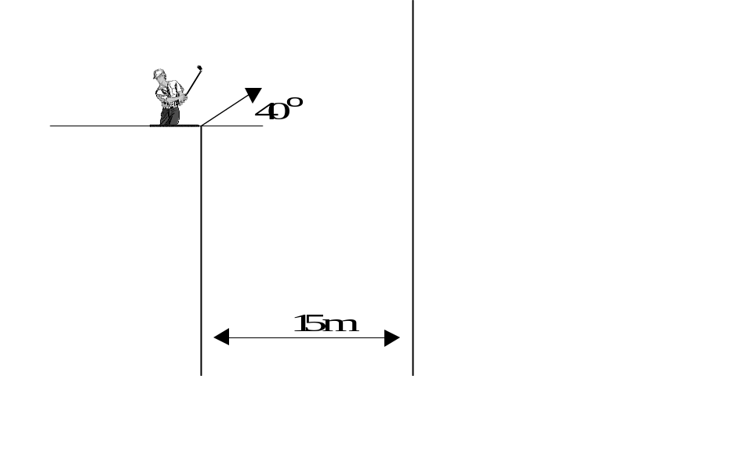Assuming no air resistance:
(a) (4 marks) Resolve the ball’s initial velocity into vertical and horizontal components, and hence,
vertical component of u = 3.86 m s⁻¹
horizontal component of u = 4.60 m s⁻¹

(b) (8 marks) Calculate how far above or below its original level the ball strikes the opposite wall.
Horizontal flight S = u t + 0.5 a t²
15 = 4.60 t + 0
t = 3.264 s
vertical flight
S = 3.86 x 3.264 + (0.5 x -9.8 3.264² )
S = -39.6m
39.6m below the take off point
(c) (4 marks) What is the ball’s speed at the instant it reaches the opposite wall?
Total Energy at launch = Total energy at wall
(E_{P} + E_{k} )= E_{k}
mgh + 0.5 m v² = 0.5 m v²
gh + 0.5 v² = 0.5 v²
(9.8 x 39.6) + 0.5 6² = 0.5 x v²
388 + 18 = 0.5 x v²
v = 28.5 m s⁻¹
(d) (4 marks) What is the direction of the ball’s velocity at the instant it reaches the opposite wall?
θ

28.5m s⁻¹

4.60 m s⁻¹
Sinθ 4.60 / 28.5
θ = 9.30° to the wall

6. (20 marks) The squirting cucumber (Ecballium elaterium) is a fruit with a very odd way of spreading its seeds. The fruit is about the size of a plum, with a thick, thorny skin. Gas collects inside and the pressure builds up. When the pressure reaches about 6 atmospheres, the fruit breaks away from the stalk and shoots off like a rocket, firing the seeds backwards. One such fruit was observed to leave at an angle of 50° to the ground, with a speed of about 10 m s⁻¹. Make and state the usual simplifying assumptions, and calculate
(a) (6 marks) The horizontal and vertical components of the initial velocity;
u_{H} = 6.43 m s⁻¹
u_{v} = 7.66 m s⁻¹

(b) (4 marks) The fruit’s time of flight;
Vertical whole flight
S = u t + 0.5 a t²
0 = 7.66 x t + (0.5 x-9.8 t² )
t = 1.56s
(c) (4 marks) The maximum height reached
Ascent data
v² = u² + 2 a s
0² = 7.66² - 19.6 s
s = 2.99m

(d) (4 marks) The fruit’s horizontal range.
Horizontal flight
S_{H} = u_{H} t
S_{H} = 6.43 x 1.56
S_{H} = 10.0m

PLEASE NOTE CORRECTION TO ACTUAL RANGE VALUE
The actual range is about 8m.
(e) (2 marks) Account for any discrepancy between the calculated and the actual range.
Air Friction or drag.
Or
The fruit was in backward motion when the seeds were emitted.
PART C: COMPREHENSION
Please answer the items in Part C in the spaces provided. This part of the examination consists of two question and carries 40 marks.
(20 marks) The passage below is from "Conceptual Physics", by Paul Hewitt (Addison-Wesley Publishing Co, 1992). Read the passage, then answer the questions at the end of it.
Black Holes

Paragraph 1
There are two main processes that are going on all the time in stars like our Sun. One process is gravitation, which tends to crunch all solar material towards the centre. The other process is nuclear fusion. The core of the Sun is continuously undergoing hydrogen-bomblike explosions that tend to blow its material out from the centre. The two processes balance each other, and the result is the Sun of a given size.

Paragraph 2
If the fusion rate increases, the Sun gets bigger; if the fusion rate decreases, the Sun gets smaller. What happens when the Sun runs out of fusion fuel (hydrogen)? The answer is, gravitation dominates and the Sun collapses. For our Sun, this collapse will ignite the nuclear ashes of fusion (helium) and fuse them into carbon. During this fusion process, the Sun will expand to become the type of star called a red giant. It will be so big that it will extend beyond the Earth's orbit and swallow the Earth. Fortunately, this won't take place until 5 billion years from now. When the helium is all fused, the red giant will collapse and die out. It will no longer give off heat and light. It will then be the type of star called a black dwarf - a cool cinder among billions of others.

Paragraph 3
The story is a bit different for stars more massive than the Sun. For stars of more than four solar masses, once gravitational collapse takes place - fusion or no fusion - it doesn't stop! The stars not only cave in on themselves, but the atoms that compose the stellar material also cave in on themselves until there are no empty spaces. What is left is compressed to unimaginable densities. Gravitation near the surfaces of these shrunken configurations is so enormous that nothing can get back out. Even light cannot escape. They have crushed themselves out of visible existence. They are called black holes.

Paragraph 4
Interestingly enough, a black hole is no more massive than the star from which it collapsed. The gravitational field near the black hole may be enormous, but the field beyond the original radius of the star is no different after the collapse than before. The amount of mass has not changed, so there is no change in the field at any point beyond this distance. Black holes will be formidable only to future astronauts who venture too close.

Paragraph 5
The configuration of the gravitational field about a black hole represents the collapse of space itself. The field is usually represented as a warped two-dimensional surface (see diagram). Astronauts could enter the fringes of this warp and, with a powerful spaceship, still escape. After a certain distance, however, they could not escape, and they would disappear from the observable universe. Don't go too close to a black hole!
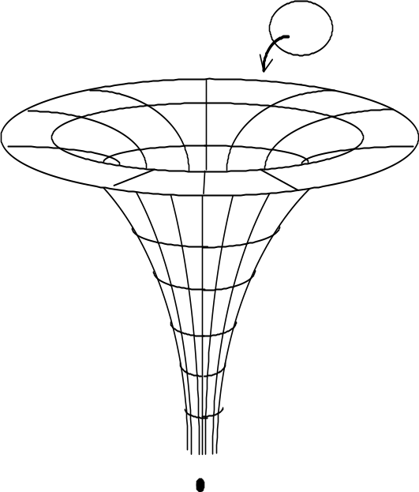
(a). (4 marks) Why does the Sun not collapse right now? (Paragraph 1)
There is a balance of the inwards force of gravity, and the outwards force caused by the fusion process.

(b). (4 marks) Calculate the force that the Sun exerts on the Earth at present.
F = G M m /r²
F = 6.67 x 10⁻¹¹ x 1.99 x 10³⁰ x 5.98 x 10²⁴ / (1.50 x 10 ¹¹ )²
F = 3.53 x 10²² N

(c). (4 marks) What force would the Sun exert on the Earth if the Sun were to collapse from its present size and become a black hole? Show your reasoning. (Paragraph 4)
The force is equal in size but opposite in direction
Newton's third law ie. Action = Reaction.

(d). (4 marks) If the Sun did collapse from its present size and become a black hole, would its gravity pull the Earth into it? Explain. (Paragraph 4)
No
The value of the g field outside the hole is not changed very much. Anyhow this acceleration is perpendicular to the velocity vector of the earth, so the Earth will continue on its path because of its Inertia.

(e). (4 marks) Will the Sun ever become a black hole? Explain. (Paragraphs 2 & 3)
No
It is not massive enough.
It will become a black dwarf star.

2. (20 marks) Read the passage below, then answer the questions at the end of it.
One method by which small amounts of metal can be heated to very high temperatures is called induction heating. The metal to be heated is placed in a ceramic or stone crucible, and then the crucible is placed inside a large solenoid that consists of several turns of thick wire.

solenoid
Chunks of metal
To be melted
Stone crucible

A high-frequency alternating current is then passed through the solenoid, usually at several hundreds of amperes. This induces large voltages in the metal in the crucible. The size of the induced voltage is given by
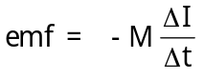
where ΔI is the size of the current change in the solenoid, Δt is the time taken for the solenoid current to change, and M is a property of the metal in the crucible.
Induction furnaces have some significant advantages over conventional furnaces that use burning fuel. The temperatures that can be attained are significantly higher, the heated metal cannot be affected by hot exhaust gases, and the crucible itself only heats up slowly as a result of heat conducting from the metal inside it to the ceramic or stone.
- (4 marks) Why does this type of furnace heat up the metal inside the crucible, but not the crucible itself?
No eddy currents are induced in the crucible since it is not a conductor.
Eddy currents heat the metal since it is a conductor.

- (8 marks) Explain why this technique requires the solenoid current to be
- large.
To cause a large amount of magnetic flux, and hence a large induced emf in the metal pieces.
- high-frequency.
To maximize the induced emf according to Faraday's induction equation.

- alternating.
Unless there is a change in magnetic flux, there will be no induction in the metal pieces. A DC supply would not produce a changing flux situation.
(c) (8 marks) Calculate the size of M if a current of frequency 2.00 kHz, having a peak value of 250 A, induces an emf of 2500 V in the metal being heated. State clearly the units of M in your answer.
Emf = -M (ΔI / t) ΔI =250 x 2 ( Peak to peak change in current value)
t = the time to go from peak max current to peak min current which is T /2 =1 / 4000 of a second = 2.50 x 10⁻⁴ s

Emf = -M (ΔI / t)
2500 - M ( 500 / 2.50 x 10⁻⁴ )
M = 1.25 x 10⁻³ VsA⁻¹
Or WbA⁻¹

end of examination paper
check your work

